Sysco Shop Nutritional/Buy American SOP
Search for the item by SUPC in Sysco Shop.
Scroll to the bottom of the page

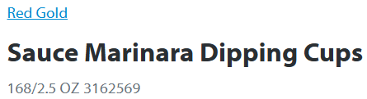
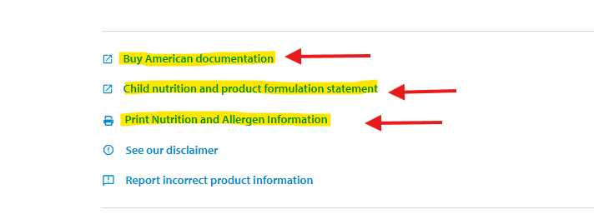

Click Buy American Link – Then print or save.
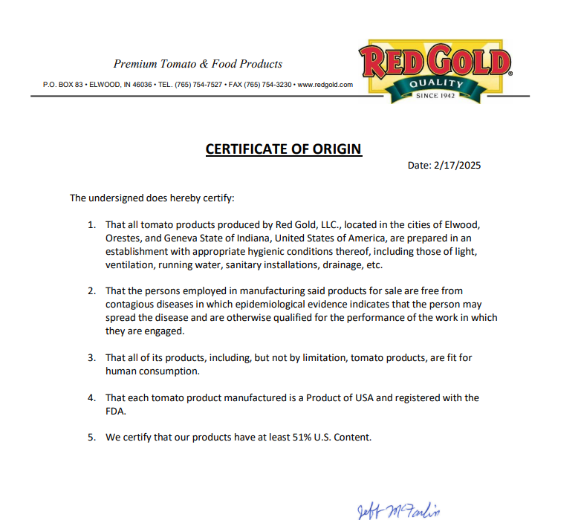
Clicking the Child nutrition and product formulation Statement
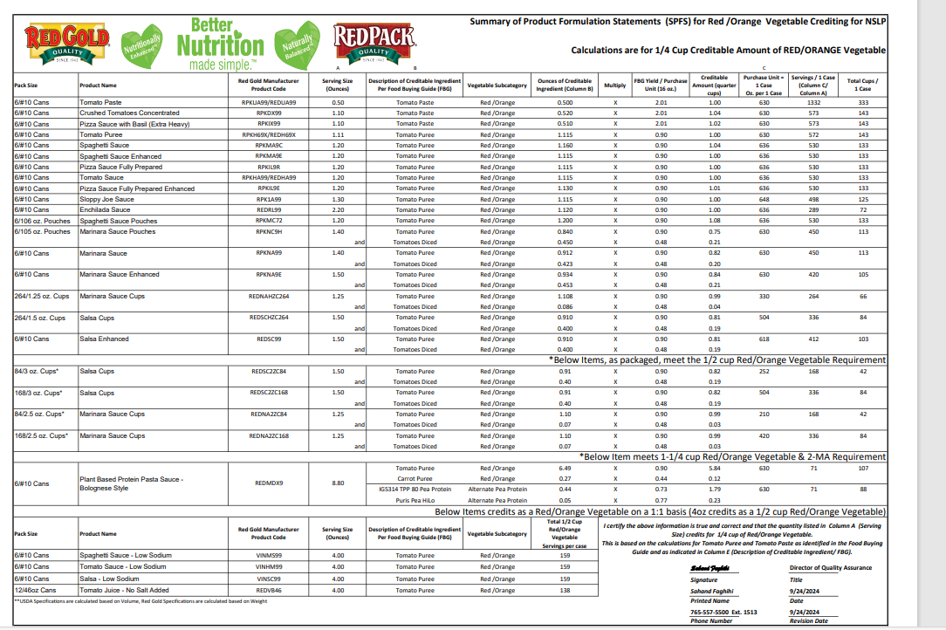

If not in Sysco Shop please reach out to your SC:
- When possible please provide the below:
  - MPC/SUPC – Brand - Description - Pack/Size

